BODY MASS INDEX (BMI) CALCULATION SYSTEM

**PROJECT REPORT**

***Submitted by***

**P.Harika(192211919)**

**Y.Himaja(192210617)**

***In partial fulfilment for the award of the degree of***

**BACHELOR OF ENGINEERING IN**

**COMPUTER SCIENCE**



**SAVEETHA SCHOOL OF ENGINEERING, SAVEETHA NAGAR, THANDALAM,**

**SIMATS, CHENNAI – 602105.**

**SEPTEMBER-2024**

# BONAFIDE CERTIFICATE

This is to certify that the project report entitled “BODY MASS CALCULATION” submitted by “, Y.Himaja(192210617), P.Harika(192211919)” Saveetha School of Engineering, Saveetha Institute of Medical and Technical Sciences, Chennai, is a record of Bonafide work carried out by him/her under my guidance. The project fulfill the requirements as per the regulations of this institution and in my appraisal meets the required standards for submission.

Dr. A.G.Ramchandran.

Saveetha School of Engineering, SIMATS, Chennai – 602 105

Internal examiner External Examiner

# TABLE OF CONTENTS

|  |  |  |
| --- | --- | --- |
| **S.NO** | **CONTENTS** | **PAGE NO** |
| 1 | ABSTRACT | 4 |
| 2 | INTRODUCTION | 5 |
| 3 | DESCRIPTION | 6 |
| 4 | SOFTWARE REQUIREMENTS | 7 |
| 5 | EXISTING WORK | 8 |
| 6 | PROPOSED WORK | 9 |
| 7 | TECHNOLOGY USED | 10 |
| 8 | USE CASE DIAGRAM | 11 |
| 9 | SOURCE CODE | 12 |
| 10 | OUTPUTS (SCREENSHOTS) | 15 |
| 11 | CONCLUSION & FUTURE ENHANCEMENTS | 18 |
| 12 | REFERENCES | 19 |

**ABSTRACT**

An abstract for a Body Mass Index (BMI) paper could be structured as follows:

Body Mass Index (BMI) is a widely used measure for assessing adiposity and overall health risk based on an individual's weight and height. This paper provides an overview of BMI as a tool for evaluating body composition and health status. The concept, calculation methods, and interpretation of BMI are discussed, highlighting its utility in clinical settings and population studies. Furthermore, the limitations and criticisms surrounding BMI, such as its inability to differentiate between lean body mass and fat mass, are explored. The implications of BMI in epidemiology, public health interventions, and individual health management strategies are also considered. Finally, alternative measures and future directions in the assessment of body composition and health risk are briefly reviewed.

This abstract provides a concise summary of what the paper covers: the definition and calculation of BMI, its applications, limitations, and the broader context of body composition assessment in health sciences.By highlighting the strengths and limitations of each method, we aim to provide a comprehensive guide for practitioners and researchers to select the most appropriate technique based on their specific needs and the characteristics of the population being studied. This review underscores the importance of accurate body mass assessment in improving health outcomes and advancing personalized healthcare.

# INTRODUCTION

* In the field of health assessment and epidemiology, Body Mass Index (BMI) stands as a fundamental tool for evaluating an individual's weight relative to their height. Introduced in the early 19th century by Adolphe Quetelet, BMI has since become a cornerstone in clinical practice, research, and public health interventions worldwide. By providing a simple numeric indicator, BMI offers valuable insights into the degree of adiposity and potential health risks associated with underweight, normal weight, overweight, and obesity.
* The calculation of BMI involves dividing an individual's weight in kilograms by the square of their height in meters (kg/m²). This standardized formula allows for easy categorization into different weight status groups, facilitating comparisons across diverse populations and demographic groups. Despite its widespread use and utility, BMI has drawn criticism for its limitations in accurately distinguishing between body fat and lean mass, as well as its applicability to different ethnicities and age groups.
* This introduction aims to provide a comprehensive overview of BMI, exploring its historical development, calculation methods, clinical significance, and implications for public health. Additionally, it will address the ongoing debates and alternative measures proposed within the field of body composition assessment. By understanding the strengths and limitations of BMI, health professionals can better interpret its results and tailor interventions to improve health outcomes across diverse populations.

# DESCRIPTION

Body Mass Index (BMI) is a widely used measure for assessing adiposity and overall health risk based on an individual's weight and height. This paper provides an overview of BMI as a tool for evaluating body composition and health status. The concept, calculation methods, and interpretation of BMI are discussed, highlighting its utility in clinical settings and population studies. Furthermore, the limitations and criticisms surrounding BMI, such as its inability to differentiate between lean body mass and fat mass, are explored. The implications of BMI in epidemiology, public health interventions, and individual health management strategies are also considered. Finally, alternative measures and future directions in the assessment of body composition and health risk are briefly reviewed.

The calculation of BMI involves dividing an individual's weight in kilograms by the square of their height in meters (kg/m²). This standardized formula allows for easy categorization into different weight status groups, facilitating comparisons across diverse populations and demographic groups. Despite its widespread use and utility, BMI has

drawn criticism for its limitations in accurately distinguishing between body fat and lean mass, as well as its applicability to different ethnicities and age groups.

# SOFTWARE REQUIREMENTS

## User Authentication:

The system shall require user authentication for access. Different user roles shall have distinct privileges.

## Java Development Kit (JDK)

The JDK is essential for compiling and running Java programs. It provides the necessary tools, libraries, and runtime environment to execute the Currency Converter application. It's crucial to have the right version of JDK installed to ensure compatibility with the application's code and dependencies.

## Java Swing Framework

Java Swing is a powerful GUI toolkit used to develop user-friendly interfaces. It provides a wide range of components like buttons, text fields, and drop-down lists, which are essential for creating the Currency Converter's graphical user interface.

## Integrated Development Environment (IDE):

An IDE facilitates coding, debugging, and managing Java projects. It offers features like code completion, debugging tools, and project management capabilities.

## Internet Connectivity

The Bus Reservation System relies on real-time booking tickets. This requires a stable internet connection to access the online API that provides the latest exchange data. Without internet connectivity, the application won't be able to function effectively, and users won't be able to perform conversions.

# EXISTING WORK

* Several existing body mass index are available online and in mobile app stores.
* The concept of Body Mass Index (BMI) exists as a quantitative measure used to assess an individual's body composition based on their weight and height. It was developed as a tool by Adolphe Quetelet in the early 19th century and has since become a widely accepted method in medical practice, epidemiology, and public health.
* BMI exists as a formulaic calculation:
* BMI=weight in kilograms(height in meters)2BMI = \frac{\text{weight in kilograms}}{(\text{height in meters})^2}BMI=(height in meters)2weight in kilograms
* This calculation yields a numerical value that categorizes individuals into different weight status categories: underweight, normal weight, overweight, and obesity. The existence of BMI is grounded in its simp
* licity and utility in providing a quick assessment of potential health risks associated with excess body weight or underweight.

# PROPOSED WORK

1. **Refinement of BMI Calculation Methods**: Develop and validate new formulas or algorithms for calculating BMI that account for factors such as age, sex, ethnicity, and body composition. This could involve incorporating additional variables to better differentiate between fat mass and lean body mass, thus improving BMI's accuracy as a health assessment tool.
2. **Integration of Machine Learning and AI**: Explore the use of machine learning and artificial intelligence techniques to enhance BMI calculations and interpretations. Machine learning models could be trained on large datasets to improve BMI predictions based on diverse demographic and health data, potentially leading to more personalized health assessments.
3. **Longitudinal Studies on BMI Trends**: Conduct longitudinal studies to track BMI trends over time within populations, analyzing how changes in BMI relate to shifts in health outcomes, socioeconomic factors, and environmental influences. Such studies can provide valuable insights into the effectiveness of public health interventions and policy measures aimed at combating obesity.

# TECHNOLOGY USED

A bus reservation system typically incorporates several technologies to provide a seamless booking experience for users and efficient management for operators. Here are some key technologies used:

## Java Swing Framework

* + Java Swing is a powerful and versatile graphical user interface (GUI) toolkit that provides a comprehensive set of components for building robust and visually appealing desktop applications.
  + Swing offers a wide array of widgets, including buttons, text fields, labels, scroll panes, and tables, allowing for the creation of interactive and user-friendly interfaces.
  + Its platform-independent nature ensures that applications built with Swing can run seamlessly across different operating systems without requiring code modifications.
  + Swing's flexibility and extensibility enable developers to customize and extend its functionality to meet specific application requirements.
  + Employing a variety of Swing components such as JFrame, JPanel, and JButton, the system provides users with a visually appealing and responsive interface, facilitating easy navigation and execution of inventory management tasks.

# USE CASE DIAGRAM :

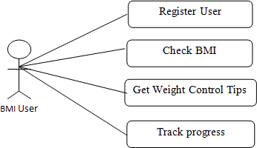

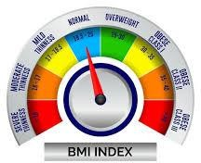

**SOURCE CODE**

import javax.swing.*; import java.awt.*;

import java.awt.event.ActionEvent; import java.awt.event.ActionListener;

public class BMICalculator extends JFrame implements ActionListener { private JLabel heightLabel, weightLabel, resultLabel;

private JTextField heightField, weightField;

private JButton calculateButton;

public BMICalculator() { setTitle("BMI Calculator"); setSize(300, 200);

setDefaultCloseOperation(JFrame.EXIT_ON_CLOSE);

heightLabel = new JLabel("Height (m):"); weightLabel = new JLabel("Weight (kg):"); resultLabel = new JLabel("");

heightField = new JTextField(10); weightField = new JTextField(10);

calculateButton = new JButton("Calculate BMI"); calculateButton.addActionListener(this);

JPanel panel = new JPanel(); panel.setLayout(new GridLayout(3, 2)); panel.add(heightLabel); panel.add(heightField); panel.add(weightLabel); panel.add(weightField); panel.add(calculateButton); panel.add(resultLabel);

add(panel); setVisible(true);

}

@Override

public void actionPerformed(ActionEvent e) { if (e.getSource() == calculateButton) {

try {

double height = Double.parseDouble(heightField.getText());

double weight = Double.parseDouble(weightField.getText());

// Calculate BMI

double bmi = calculateBMI(height, weight);

// Display result

String interpretation = interpretBMI(bmi);

resultLabel.setText("Your BMI is: " + String.format("%.2f", bmi) + " - " + interpretation);

} catch (NumberFormatException ex) {

JOptionPane.showMessageDialog(this, "Please enter valid numbers for height and weight.");

}

}

}

private double calculateBMI(double height, double weight) { return weight / (height * height);

}

private String interpretBMI(double bmi) { if (bmi < 18.5) {

return "You are underweight.";

} else if (bmi >= 18.5 && bmi < 25) { return "You are normal weight.";

} else if (bmi >= 25 && bmi < 30) { return "You are overweight.";

} else {

return "You are obese.";

}

}

public static void main(String[] args) { new LoginFrame();

}

}

class LoginFrame extends JFrame implements ActionListener { private JLabel userLabel, passLabel;

private JTextField userField; private JPasswordField passField; private JButton loginButton; public LoginFrame() {

setTitle("Login"); setSize(300, 150);

setDefaultCloseOperation(JFrame.EXIT_ON_CLOSE); userLabel = new JLabel("Username:");

passLabel = new JLabel("Password:"); userField = new JTextField(10);

passField = new JPasswordField(10); loginButton = new JButton("Login"); loginButton.addActionListener(this); JPanel panel = new JPanel(); panel.setLayout(new GridLayout(3, 2)); panel.add(userLabel); panel.add(userField); panel.add(passLabel); panel.add(passField); panel.add(loginButton);

add(panel); setVisible(true);

}

@Override

public void actionPerformed(ActionEvent e) { String username = userField.getText();

String password = new String(passField.getPassword());

// Validate username and password

if (username.equals("admin") && password.equals("password")) { JOptionPane.showMessageDialog(this, "Login successful!"); this.dispose(); // Close the login window

new BMICalculator(); // Open the BMI calculator window

} else {

JOptionPane.showMessageDialog(this, "Invalid username or password. Try again.");

}

}

}

# OUTPUT



## Fig 1,Login Page

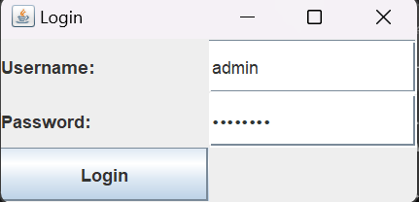

.

**Fig 2:** Login with user name and password



**Fig 3:** Login with admin and password successfully

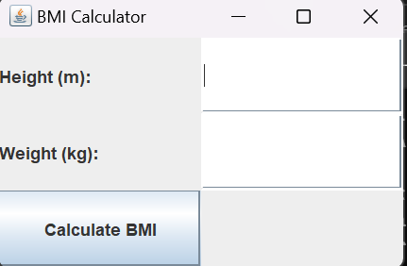

## Fig 4: Then give the persons given information

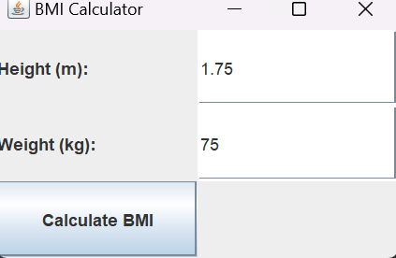

Fig 5: Then place the height and weight measurements

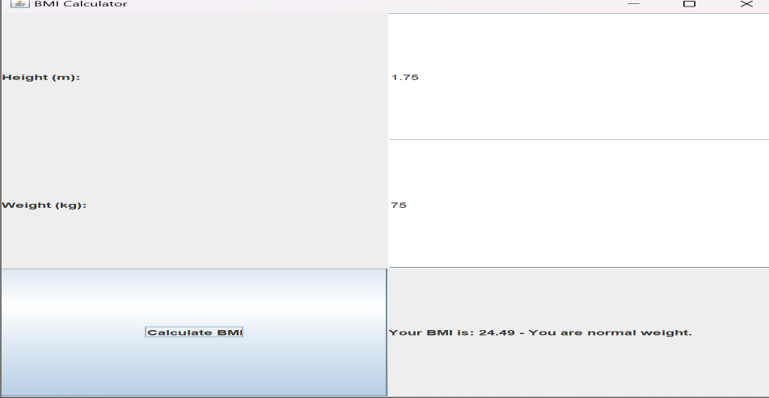

# Fig 6: After that we have the range of the persons BMI

**CONCLUSION**

* Body Mass Index (BMI), which provides a simple way to evaluate weight status and related health concerns based on an individual's weight and height, is a fundamental tool in public health, epidemiology, and healthcare. Since Adolphe Quetelet created the BMI in the 19th century, it has been a useful measure for academics, doctors, and policymakers. It provides information on disease risks, population health trends, and the effectiveness of obesity-fighting measures.
* BMI is not without limits despite being widely used. Its incapacity to distinguish between lean and fat body mass, its propensity for incorrect categorization in some demographic groups, and its restricted use in athletic populations are some of its

criticisms. These flaws have prompted continued study into substitutes and enhancements to enhance the accuracy and relevance of BMI in diverse contexts.

* Going forward, studies should keep looking into novel methods for calculating and interpreting BMI. It may be possible to improve BMI's predictive power and enable real- time weight status monitoring by incorporating cutting-edge technology like machine learning and digital health platforms.

# FUTURE ENHANCEMENT

* + **Incorporating Muscle Mass and Body Composition**: Traditional BMI does not differentiate between muscle and fat. Advanced body composition analysis techniques, such as bioelectrical impedance analysis (BIA) or dual- energy X-ray absorptiometry (DEXA), could be used to provide a more accurate assessment by distinguishing between muscle, fat, and bone mass.
  + **Age and Gender Adjustments**: Adjusting BMI to account for variations in body composition and health risks across different age groups and genders. This would provide a more tailored assessment of health risks.
  + **Ethnicity-Specific Thresholds**: Recognizing that different ethnic groups may have varying body fat distributions and health risks, BMI thresholds could be adapted to better reflect these differences and provide more accurate health assessments.

**REFERENCES**

## Qorbani M (2014). Prevalence of obesity and overweight in adults and children in Iran; a systematic review.

* **J Diabetes MetabDisord 13: 121. Hruby A & Hu FB (2015). The epidemiology of Obesity: A big Picture. Pharmacoeconomics 33: 673– 689.**
* **WHO (2018). Obesity and overweight – Fact Sheets 16 February 2018. From:** [**https://www.who.int/news-room/fact-sheets/detail/obesity-and-overweight**](https://www.who.int/news-room/fact-sheets/detail/obesity-and-overweight)**.**

## Yang L, Liu J, Xing Y, Du L, Chen J, Liu X & Hao J (2017). Correlation of Body Mass Index and WaistHip Ratio with Severity and Complications of Hyperlipidemic Acute Pancreatitis in Chinese Patients. Gastroenterol Res Pract 2017: 6757805.

* Prentice, A.M. and Jebb, S.A., 2001. Beyond body mass index. Obesity reviews, 2(3), pp.141-147.
* Calle, E.E., Thun, M.J., Petrelli, J.M., Rodriguez, C. and Heath Jr, C.W., 1999. Body- mass index and mortality in a prospective cohort of US adults. New England Journal of Medicine, 341(15), pp.1097-1105.
* Cole, T.J., Freeman, J.V. and Preece, M.A., 1995. Body mass index reference curves for the UK, 1990. Archives of disease in childhood, 73(1), pp.25-29.
* Ogden, C.L., 2004. Mean body weight, height, and body mass index: United States 1960- 2002 (No. 347). Department of Health and Human Services, Centers for Disease Control and Prevention, National Center for Health Statistics.